**Medicare Provider Utilization and Payments**

**IBM Watson Project**

**Guided by: Dr. Shilpa Balan**

**California State University Los Angeles**

**By**

**Lakshmi Sundararajan**

1. **Data Source and Data Set:**

<https://public.enigma.com/>

<https://public.enigma.com/datasets/medicare-provider-utilization-and-payments-2014/23637849-b62d-4065-8d93-c52a1cc04f27>

1. **Data Description:**

The data used in this analysis is taken from enigma. It contains information on services and procedures provided to Medicare beneficiaries by physicians and other healthcare professionals. It contains information on utilization, payment (allowed payment and Medicare payment), and submitted charges organized by National Provider Identifier (NPI), Healthcare Common Procedure Coding System (HCPCS) code, and place of service (3). Average of the Medicare allowed amount for the service; this figure is the sum of the amount Medicare pays, the deductible and coinsurance amounts that the beneficiary is responsible for paying, and any amounts that a third party is responsible for paying. Average of the charges that the provider submitted for the service is Average submitted charged amount. Average amount that Medicare paid after deductible and coinsurance is the Average Medicare Payment Amount. HCPCS is a set of healthcare procedure codes based on the American Medical Association Current Procedural Terminology. The Medicare payment is monitored by the prospective payment system (PPS) that has profoundly changed the structure of physician charges under Medicare. The proportion of allowed physician charges originating in an inpatient hospital setting was drastically reduced (4). This dataset contains information on allowed payment and actual payment which helps in comparing the average Medicare allowed payment. It also has details about average Medicare allowed amount, average submitted charge amount, average Medicare payment amount and average Medicare standard amount.

1. Data Refinement:

|  |  |  |
| --- | --- | --- |
| SCOPE / PROBLEM | DIRTY DATA | CLEANED DATA |
| Removal of null values |  | Null values removed |
| Wrong Refer-ence Removal |  |  |
| Rename Column  Name |  |  |
| Applying  Filter |  | We can apply filters to average submitted charge amount.  But it is not required for my analysis at this time. |
| Eliminating unused column |  |  |

DATA GROUPING

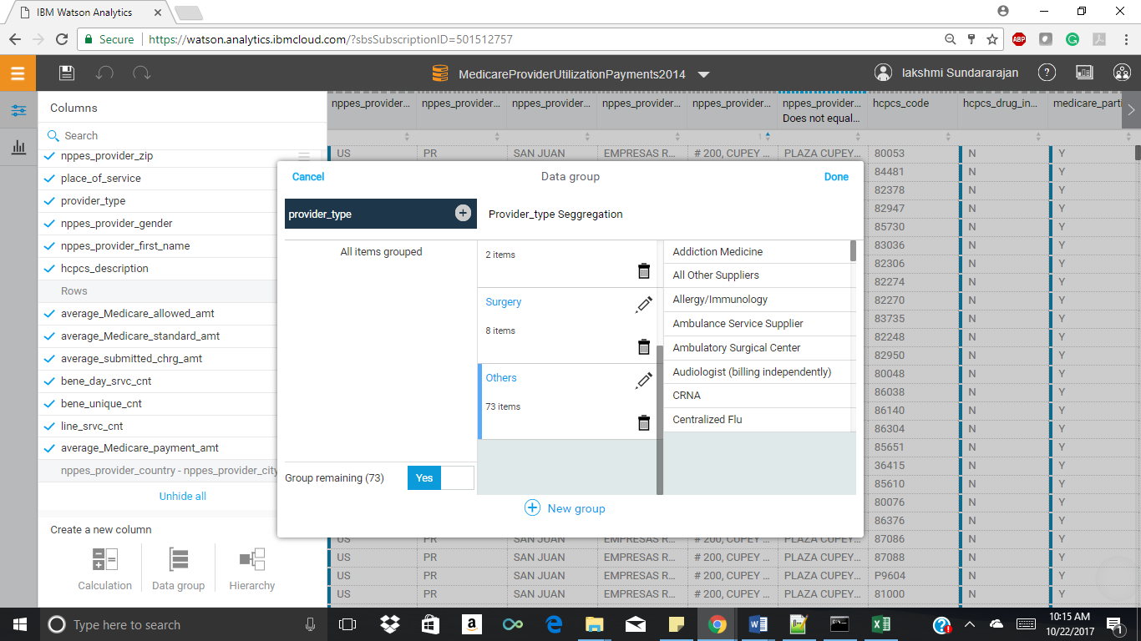

Data Grouping for the column Provider type that consists of the type of services for which Medicare payments is provided. The data was grouped into cardiac, neuro, surgical, and others. These were just few types which had multiple services and named Provider Type Segregation. Hence grouping of these helps in better analyzation.

CALCULATION

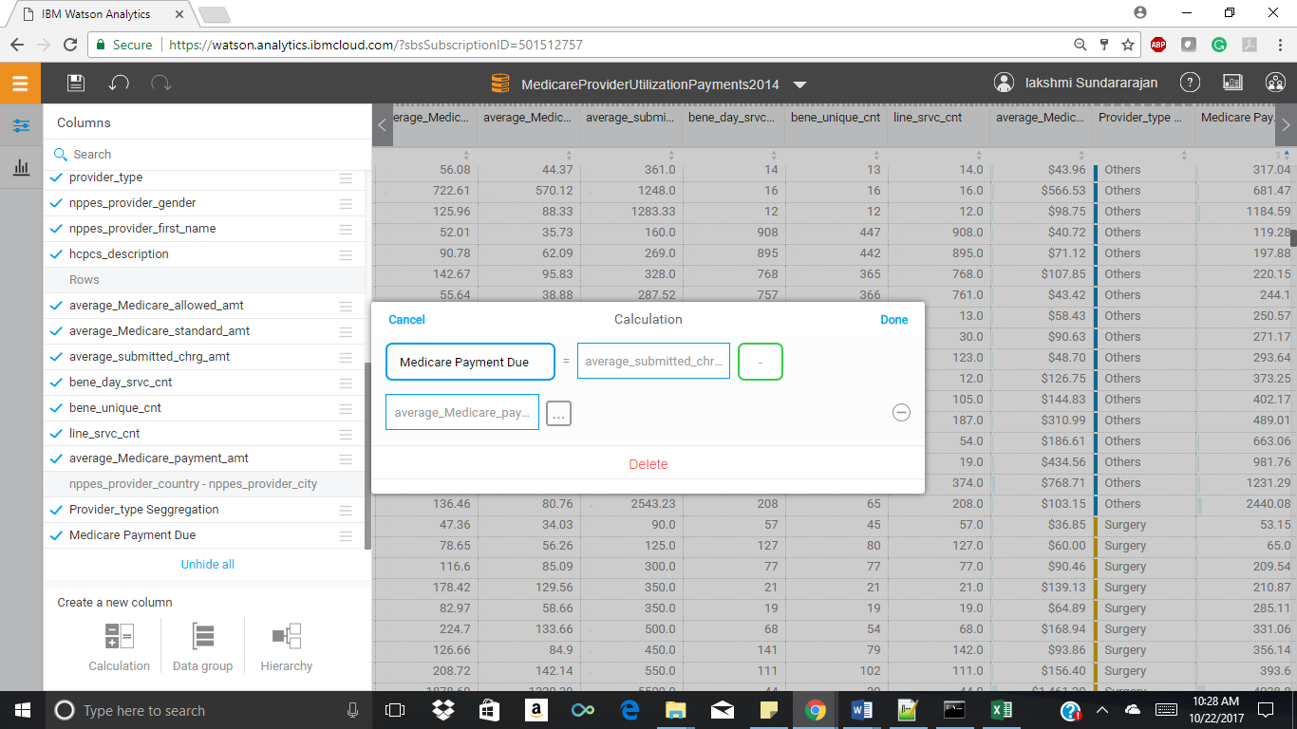

Data calculation was performed for two fields i.e. average submitted charge amount and average Medicare payment amount. The difference between these two gives the Payment due that wasn’t refunded. That field was named as Medicare Payment Due. Using this field, it is easier to compare the payments.

1. Data Quality: (hashtag data set need not be included)

QUALITY BEFORE REFINEMENT

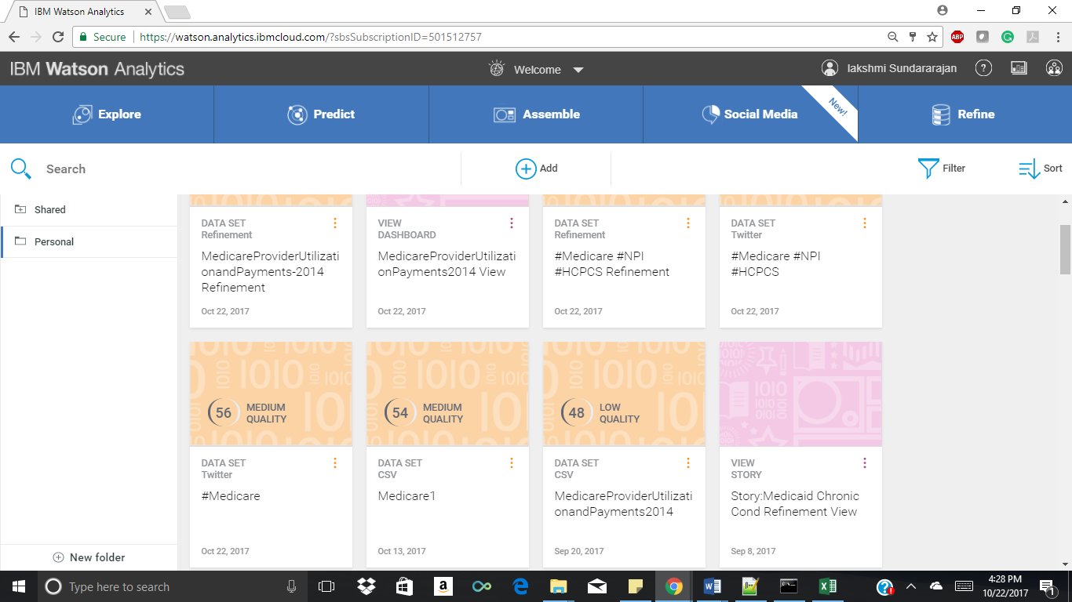

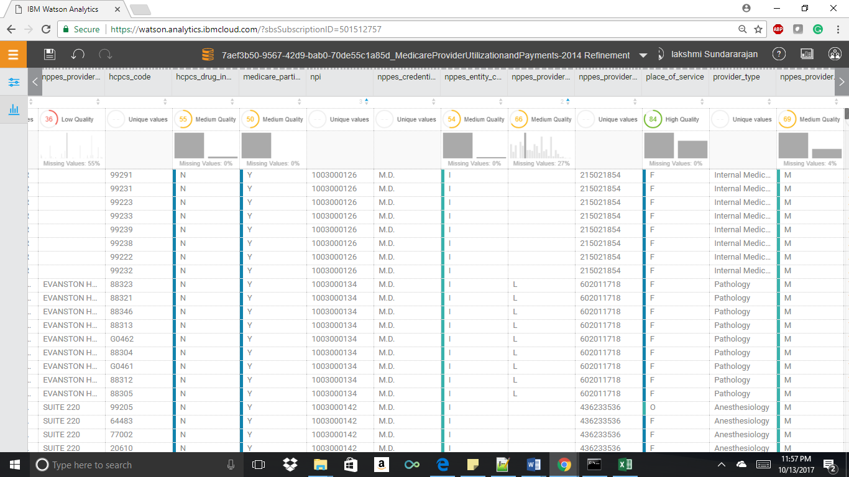

QUALITY AFTER REFINEMENT

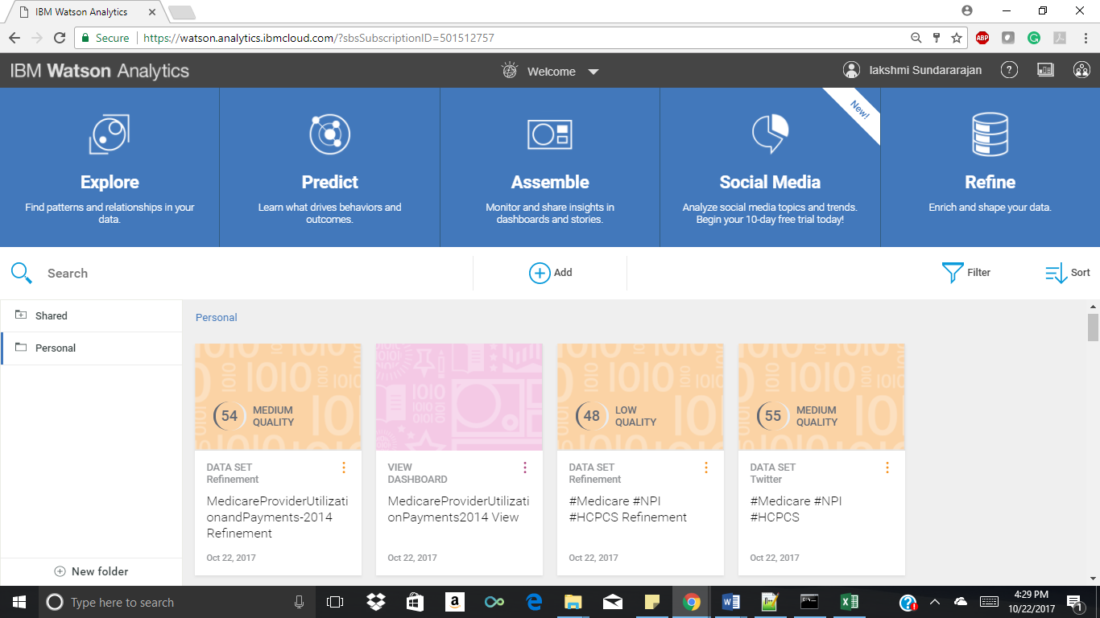

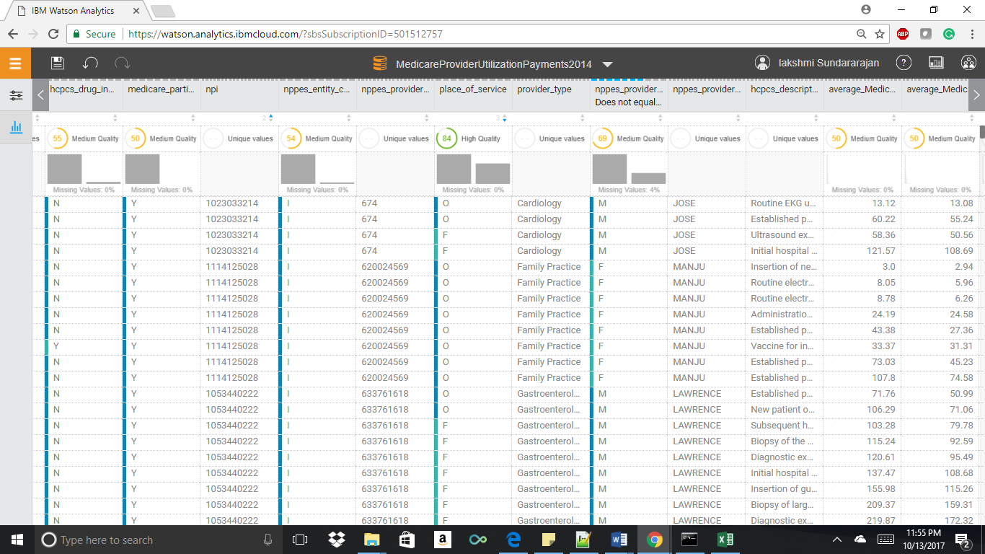

1. Data Exploration:
2. What are the values of average Medicare allowed amount by NPPES provider state?

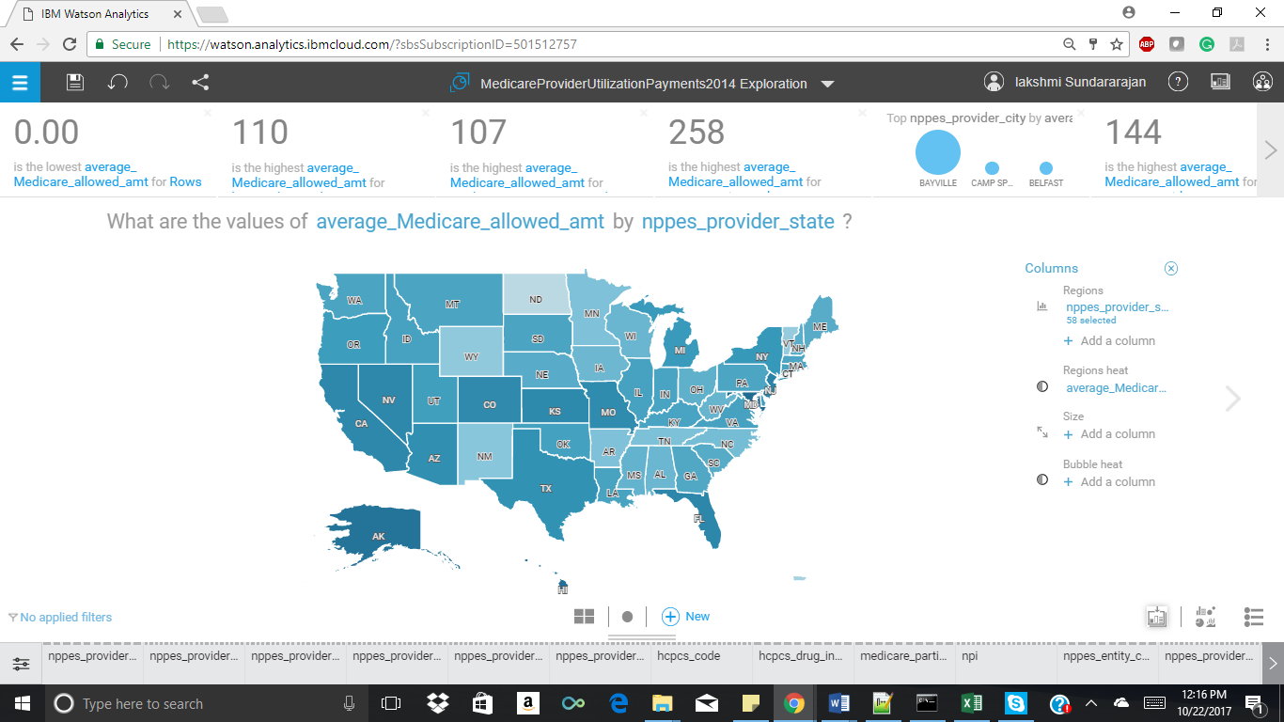

In this visualization, we check what is the average Medicare allowed amount allocated for different states. It is represented using a geographical map. It displays the amount spent on Medicare by each state. This data is useful to know the state wise allocated Medicare expenses and check if it is reasonable for that state. For Example: The average Medicare allowed amount in California is 111.75 whereas for Oregon it is only 89.66.

1. How do the values of average Medicare allowed amount compare by provider type segregation?

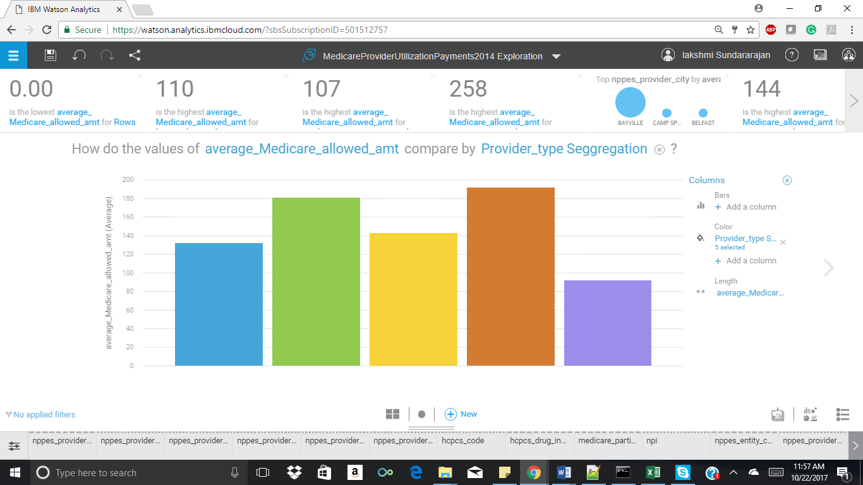

In the above visualization, we compared the average Medicare allowed amount for different provider type segregation. The second field in comparison has been grouped into cardiac, neuro, Anesthesia, surgery and others, which was given under the color option. Blue: Cardiac, Green: Others, Yellow: neuro, Brown: Surgery and Violet: Anesthesia. This shows the amount allocated for each of the major service groups. With this visualization we can know that amongst all the service groups surgery has the maximum Medicare amount allocated.

1. How do the values of Medicare Payment Due compare by Provider Type Segregation and NPPES provider state?

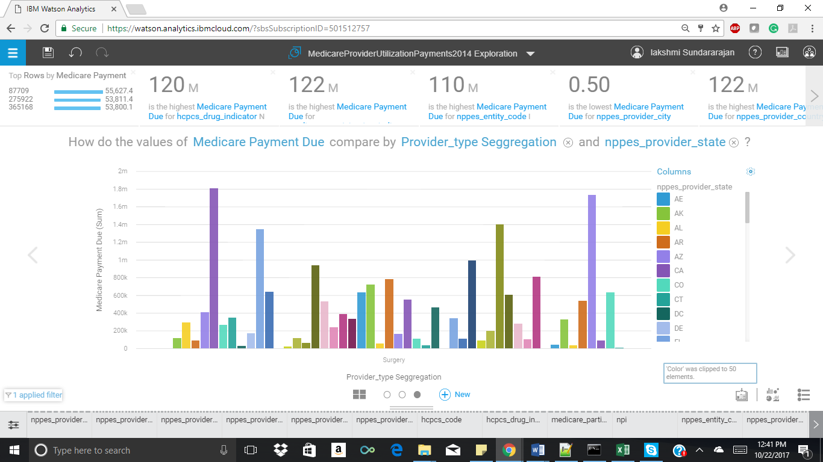

In the above visualization, we compared the values of Medicare Payment Due which is the difference between Average submitted charged amount and Average payment amount. This field gives the insight on what was deducted or yet to refund charges. We can view the charges of each provider type group separately. Since surgery was found to be highest payment services this visualization was filtered to know the payment due in surgery services with respect to state.

1. What is the trend of Author Tweet Count over Hashtags?

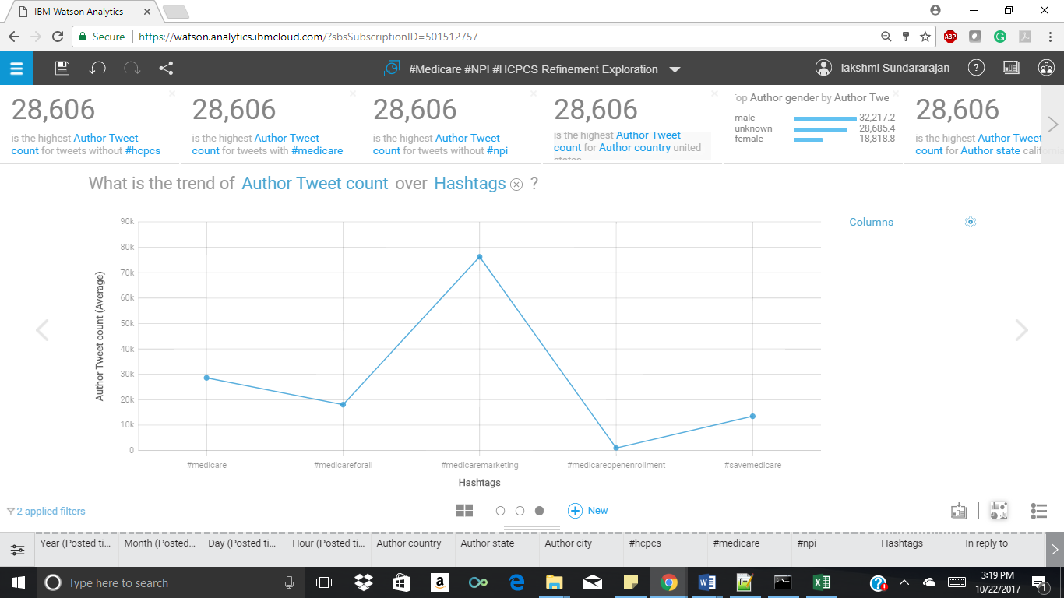

This visualization was taken from the #Medicare #HPI #HCPCS twitter hashtags. Here we can see the trend analysis of author tweet count over Medicare related hashtags. The Medicare related hashtags include #Medicare #Medicare marketing #Medicare open enrollment #save Medicare #Medicare for all. Amongst these we can see Medicare marketing has the highest number of tweets.

1. Prediction

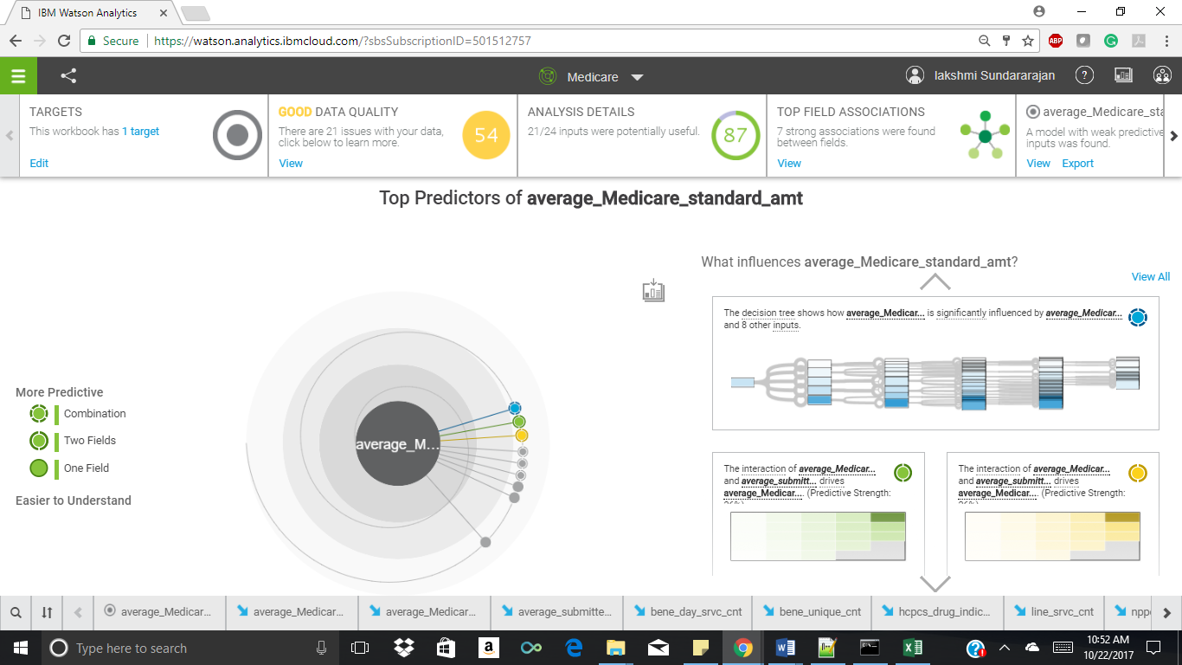

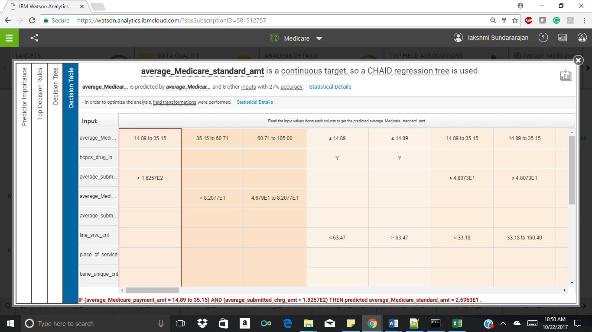

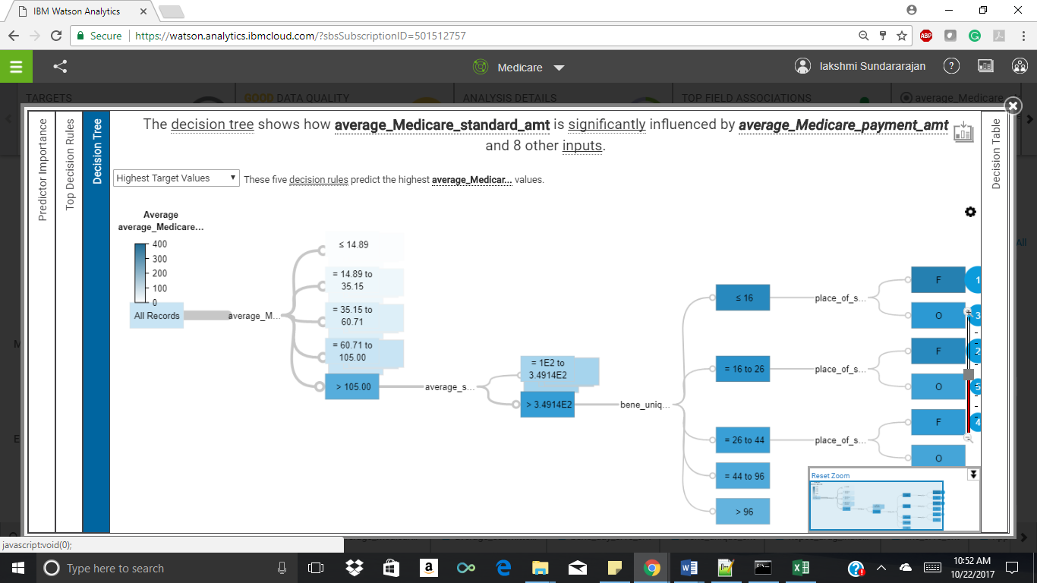

The prediction is done on Average Medicare Standard amount which is the Average amount that Medicare paid after beneficiary deductible and coinsurance amounts have been deducted for the line item service and after standardization of the Medicare payment has been applied. Standardization removes geographic differences in payment rates for individual services, such as those that account for local wages or input prices and makes Medicare payments across geographic areas comparable. According to the prediction the decision tree shows that this factor for prediction is influenced by the average Medicare payment amount. With respect to the decision table since Average Medicare Standard amount is a continuous value which will keep changing depending on the current day circumstances it has used a CHAID (chi-squared automatic interaction detection) regression tree algorithm. The condition used for this prediction is as follows:

If (Average Medicare payment amount = 14.89 to 35.15) AND (average submitted charged

amount > 1.8257E2) THEN predicted Average Medicare standard = 2.6963E1.

This condition states that if average Medicare payment amount is in the range 14.89 to 35.15 And average submitted charged amount should be greater than 1.8257E2 then predicted Average Medicare standard is 2.6963E1. The predictive strength in the bulls eye is 24.1 percent. This strength is calculated by two major fields one is Average Medicare Payment Amount and Average submitted charged amount.

1. Dashboard

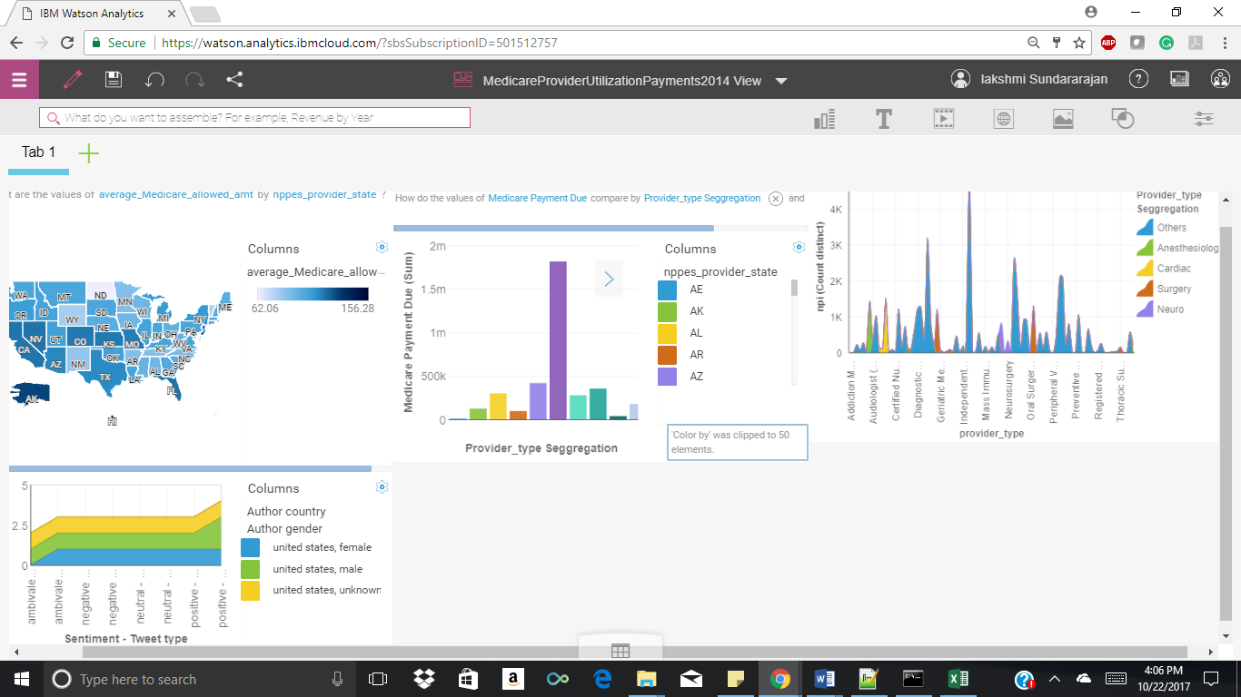

References

1. Richard A Bauder ,Taghi M Khoshgoftaar  ,July 2016 , ‘A Novel Method for Fraudulent Medicare Claims Detection from Expected Payment Deviations’ <http://ieeexplore.ieee.org/abstract/document/7785720/?reload=true>

# SAS Student Symposium, January 2016, ‘An analysis of Medicare Provider Utilization and Payment Data: A focus on the top 5 DRGs and mental healthcare’

# <http://support.sas.com/resources/papers/proceedings16/12527-2016.pdf>

1. 2014, ‘Medicare Provider Utilization and Payments’

<https://public.enigma.com/datasets/medicare-provider-utilization-and-payments-2014/23637849-b62d-4065-8d93-c52a1cc04f27>

1. [Charles R. Fisher](https://www.ncbi.nlm.nih.gov/pubmed/?term=Fisher%20CR%5BAuthor%5D&cauthor=true&cauthor_uid=10312185) , ‘Impact of the prospective payment system on physician charges under Medicare’<https://www.ncbi.nlm.nih.gov/pmc/articles/PMC4192857/>